Shayaan Khan (S00199152) Website Project

**Introduction:**

My website is an information website on sports, where I discuss the HISTORY, the RULES and HOW TO PLAY the following sports – Cricket, Badminton, Tennis and Table Tennis. The intended audience for this website is anyone looking to pursue a career in sports, particularly the sports discussed on my website, or for anyone looking to acquire a hobby to keep themselves active and in good shape.

**GitHub Links:**

GitHub URL to open my website on a browser:

<https://s00199152.github.io/Web-Design-Project/>

GitHub URL to my repository:

<https://github.com/S00199152/Web-Design-Project>

**Original Mockup Sketch of Website Home Page:**

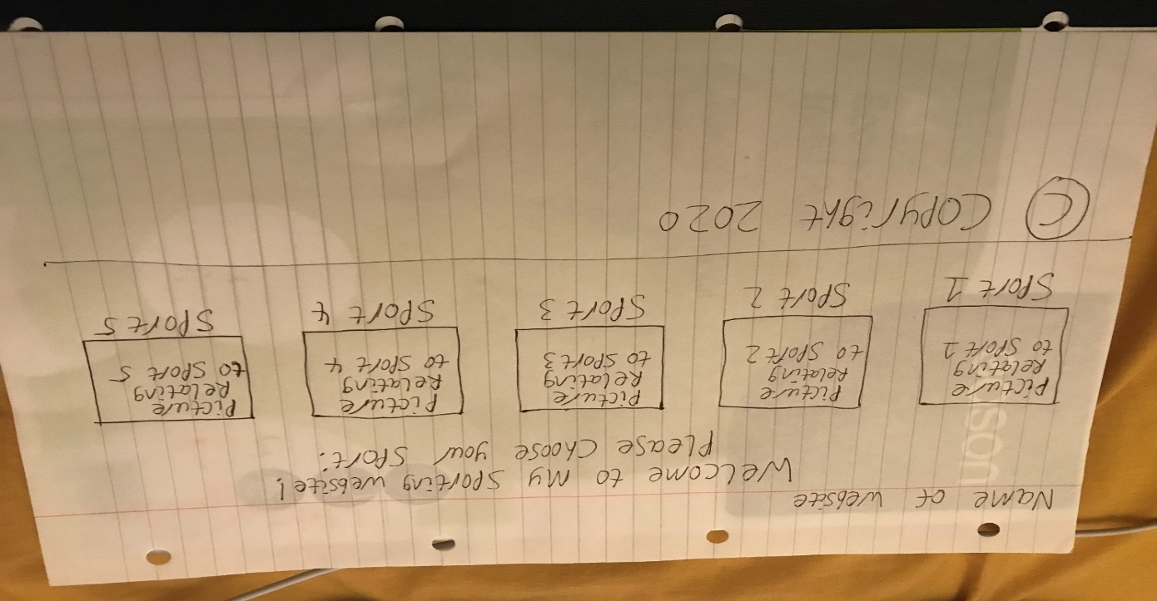

**Page 1 Explanation:**

This page introduces you to my website and you will be explained to about the purpose of my website and who is this website directed at. Following that, is the introduction to sport – what is it, where did the word originate from. Then you will see some Google Maps of a few sports shops in Sligo. And then you can choose which of the sports mentioned above you wish to explore and will be directed to the respective page of your choice. You can also see a list of sports on the right-hand side of the page after the choice section that I have sorted from A-Z (no X as there is no sport starting with the letter X). **You will see the same list on Pages 2-5.**

Sources of Information: <https://en.wikipedia.org/wiki/Sport>

Image Sources: <https://tenor.com/view/welcome-gif-10939070>

* <https://images.app.goo.gl/FxusGr8GGuWkYjai9>

* <https://images.app.goo.gl/mQQg1gYCaDUmECsi6>

* <https://images.app.goo.gl/RyzDWvFJ8nK56QGJ9>

* <https://images.app.goo.gl/GeuPNfKdpmGQZEKR9>

*also used on other pages for choice sections

**Page 2 Explanation:**

The Cricket Page. First of all you will see a couple of images – a view of a typical cricket stadium and cricket being played, followed by some background history of the sport. Then you will learn the rules of cricket and how to play it, with another image of cricket being played. You will then see a table displaying 4 Cricket Venues in Ireland, showing the city each venue is based in, the provincial union, the capacity of the venue and what year it was first used in. Then you will see a couple of links to different page to find out more about the HISTORY of the sport and the RULES of the sport. You will then be able to choose which of the other sports you would like to explore. **The explanation for pages 3-5 are pretty much the same, EXCEPT FOR THE TABLE.**

Sources of Information: <https://www.historic-uk.com/CultureUK/The-History-of-Cricket/>

<https://www.myactivesg.com/Sports/Cricket/How-To-Play/Cricket-for-Beginners/Rules-of-Cricket>

<https://en.wikipedia.org/wiki/Cricket_in_Ireland>

Image Sources: <https://images.app.goo.gl/aT1m74NbduJDtwzG9>

<https://images.app.goo.gl/CFy2FDN1GN2My3vb7>

<https://www.myactivesg.com/Sports/Cricket/How-To-Play/Cricket-for-Beginners/Rules-of-Cricket>

**Page 3 Explanation:**

**\*Same explanation as page 2\*** Badminton Page. Images shown at the top are an indoor badminton court and the equipment required to play badminton. Image on the Rules section is badminton being played on an indoor court.

Sources of Information: <https://www.britannica.com/sports/badminton>

<https://www.badmintonbible.com/rules/simple>

Image Sources: <https://images.app.goo.gl/4rU8XEtapektoVx88>

<https://images.app.goo.gl/6kq7XempcDMYefJX9>

<https://images.app.goo.gl/g5pCwEtTMrtCvB547>

**Page 4 Explanation:**

**\*Same explanation as page 2\*** Tennis Page. Image shown at the top is an underwater tennis court. Image on the Rules section is badminton being played on an indoor court.

Sources of Information: <https://www.britannica.com/sports/tennis>

<https://www.britannica.com/sports/tennis/Principles-of-play>

Image Sources: <https://images.app.goo.gl/NfBVjGVytPBBxc118>

<https://images.app.goo.gl/w5VuoKNBMSGvZm6Q6>

**Page 5 Explanation:**

**\*Same explanation as page 2\*** Table Tennis Page. Image shown at the top is a table tennis court. Image on the Rules section is table tennis being played.

Sources of Information: <https://www.britannica.com/sports/table-tennis>

<http://www.pongworld.com/table-tennis-sport/rules>

Image Sources: <https://images.app.goo.gl/u47d4YneZzBw8Zwf8>

<https://images.app.goo.gl/LiaWmRcHZC7Y5vP4A>

**Page 6 Explanation:**

Video Page. YouTube videos that discuss the HISTORY and RULES of the same sports I discussed.

**Page 7 Explanation:**

Feedback/Query Page. Any feedback or queries you have about my website can be submitted by completing an submitting the form.

Image Source: <https://tenor.com/view/natsuko-honda-thumbs-up-anime-gif-9928402>

**HTML5 Validation Results for each Web page:**

**Page 1 Validation Results:**

**Page 2 Validation Results:**

**Page 3 Validation Results:**

**Page 4 Validation Results:**

**Page 5 Validation Results:**

**Page 6 Validation Results:**

**Page 7 Validation Results:**

**CSS Validation Results:**

**Project Checklist:**

**You are asked to complete an original website of your own work, the website should contain the features listed below.**

Create a website using html5/css that will include the below Project Check List elements: if features are not obvious outline where they are located on the web page below. In order to mark the project the student will present the website and explain the code, declaration of own work submitted.

|  |
| --- |
| **\*\*\*\*Must include Report including purpose and intended audience of the website and sources of images and information of each web page and HTML & CSS validation results. Upload completed project include url in report** |
| **Minimum of 4 HTML Pages with navigation menu not dummy text, use text and hyper link from appropriate website** ( outline college project on landing page, do not include any personal or college information in the content of the pages) |
| **Upload progress and completed website to your GitHub account** |
| **HTML5 standards and recommended page layout structure** (header,main,aside,article,footer,etc) |
| **Include appropriate Meta data – description & appropriate keywords etc to improve pages SEO** |
| **Include font family for web page body** |
| **Appropriate use of External Style Sheet – Recommended CSS (**standard for majority of your CSS) |
| **Appropriate use of Internal & Inline Styling on HTML page** (one example of each) both on Page 7 (form page) |
| **Home page content aligned to each other and visually attractive** |
| **Include navigation above fold and bottom of web pages- Indicate on navigation the current page** |
| **Include both Class and ID as CSS Selectors** |
| **Consistency of design on all pages , use of fonts, colour etc** |
| **Appropriate use of Headings (h1, h2, h3, h4)** |
| **Appropriate use of Colours (test for colour blind users)** |
| **Include an article or section with 2 or 3 columns** (by using appropriate css) |
| **Include logo and display in header of page** |
| **Clear, consistent and align content on all pages** (reference all sources) |
| **Include images (with at least one image floated with text alongside)** |
| **Use of background image** |
| **Include table of data/information only for statistical data** on page 2 (Cricket Page) |
| **Include lists ordered or unordered (different shaped bullet points)** on pages 2-5 |
| **Include a link to a suitable video and google map –** use iframe code from YouTube or google maps from share, embed, copy iframe into your html page videos on page 6 (Video Page) and google maps on page 1 (Home Page) |
| **Include a contact me form and include red * beside required/mandatory input fields** |
| **Verify data collected on contact form, using get and data attached to URL** (Use the method get to display values entered on form will be appended to url and passed to server <form action=" [http://year1.ccpdev.me/FormTest.php](http://year1.ccpdev.me/FormTest.php?fdf=fdsaf&fdsfs=hfdsahfkjhfa)" method="get"> |
| **Footer information including Copyright© 2020 and navigation** |
| **Internal anchor Links on one of the webpages** |
| **External Link to external website** on pages 2-5 (Cricket, Badminton, Tennis and Table Tennis Pages) |
| **Any Additional Features included __________________** |
| **Results included in report of HTML5 Validation (with majority of issues addressed)** |
| **Results included in report of CSS Validation (with majority of issues addressed)** |
| **☐R Include Favicon on the Title tab** | |
| **Guide line on Website appearance, design and Content** [**https://webdesignledger.com/10-signs-of-a-user-focused-design/**](https://webdesignledger.com/10-signs-of-a-user-focused-design/) | |
| **Guidelines on Website overall appearance & design** [**https://webdesignledger.com/20-dos-and-donts-of-effective-web-design/**](https://webdesignledger.com/20-dos-and-donts-of-effective-web-design/) | |